**Introduction**

**The purpose of this Project is to help people in exploring better facilities around their neighborhood. It will help people making smart and efficient decision on selecting great neighborhood out of numbers of other neighborhoods in York, Toranto.**

**Lots of people are migrating to various states of Canada and needed lots of research for reputated schools for their children. This project is for those people who are looking for better neighborhoods.**

**This Project aim to create an analysis of features for a people migrating to York to search a best neighborhood as a comparative analysis between neighborhoods. The features include better school according to ratings.**

**It will help people to get awareness of the area and neighborhood before moving to a new city, state, country or place for their work or to start a new fresh life.**

**Data Section**

**Data Link:**[**https://en.wikipedia.org/wiki/List_of_postal_codes_of_Canada:_M**](https://en.wikipedia.org/wiki/List_of_postal_codes_of_Canada:_M)

**Foursquare API Data:**

**We will need data about different venues in different neighborhoods of that specific borough. In order to gain that information we will use "Foursquare" locational information. Foursquare is a location data provider with information about all manner of venues and events within an area of interest. Such information includes venue names, locations, menus and even photos. As such, the foursquare location platform will be used as the sole data source since all the stated required information can be obtained through the API.**

**After finding the list of neighborhoods, we then connect to the Foursquare API to gather information about venues inside each and every neighborhood. For each neighborhood, we have chosen the radius to be 100 meter.**

**The data retrieved from Foursquare contained information of venues within a specified distance of the longitude and latitude of the postcodes. The information obtained per venue as follows:**

**1. Neighborhood**

**2. Neighborhood Latitude**

**3. Neighborhood Longitude**

**4. Venue**

**5. Name of the venue e.g. the name of a store or restaurant**

**6. Venue Latitude**

**7. Venue Longitude**

**8. Venue Category**

**METHOD**

1. **Finding the most common venues near York neighborhood**

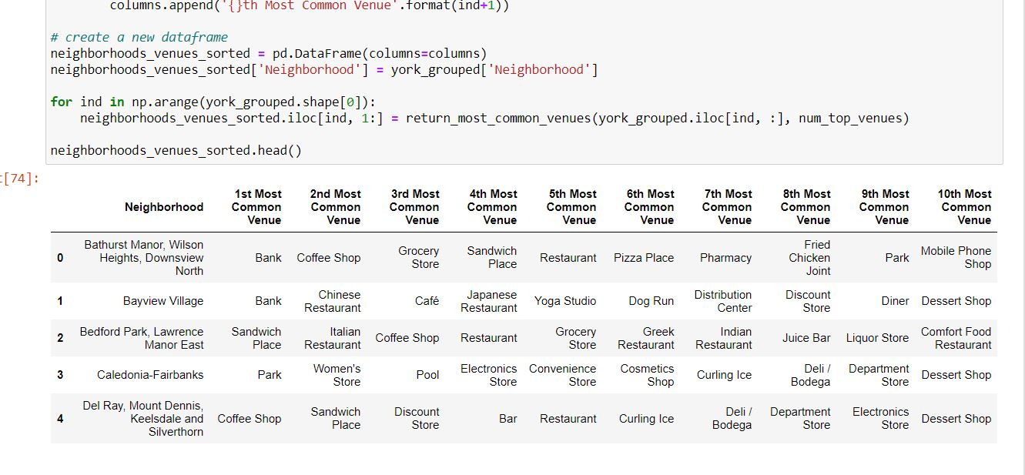

1. **Using k means clustering method**

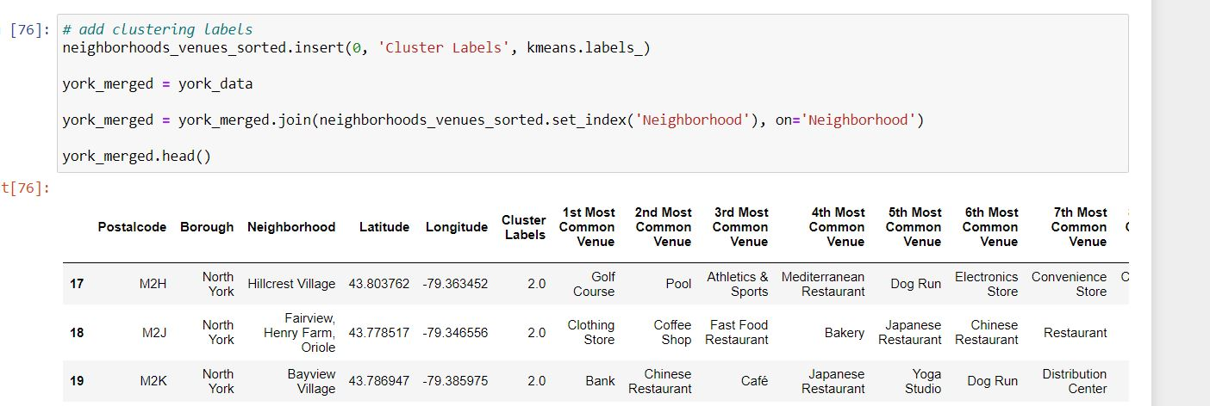

**FINAL RESULTS**

1. **CLUSTERED MAP**

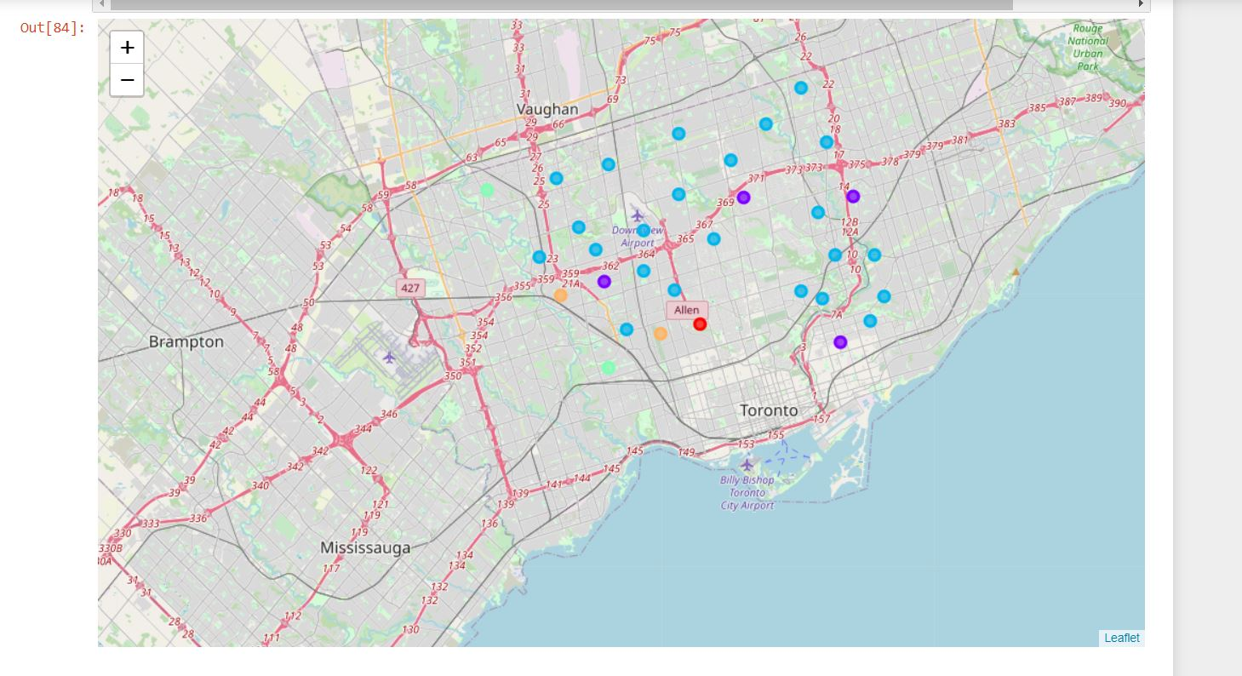

1. **SCHOOL RATINGS**

